**Faculty of Information Technology**

**Automated Camera Stand**

Group 47

|  |  |
| --- | --- |
| **P.A.U.D. Herath** | **204074M** |
| P.H.P. Jayathilaka | 204087F |
| D.M.B.M. Dissanayake | 204047J |
| S.P.S.N. Pathirana | 204150T |
| A.M.D.B. Rathnayaka | 204179N |
| Supervisor’s Name: Mr. B.H. Sudantha  Dean/Senior Lecturer  Faculty of Information Technology    Signature of Supervisor: ……………………………. | Ms. Chanduni Gamage  Lecturer  Dept. of Information Technology      ……………………………. |

Date of Submission: 30/11/2021

# Table of Content

Table of Content i

Table of Figures ii

1 Introduction 1

2 Literature Survey 2

3 Aim & Objectives 3

4 Analysis and Design 4

5 Testing and Implementation 6

6 Previous Action Plan 9

7 Action Plan for Remaining Work 9

Appendix A 11

8 Cost Estimation and Expenditure so far 11

*Appendix B* 12

9 Individual Contribution to the Project 12

*Appendix C* 17

References 17

# Table of Figures

Figure 2‑1 Beetle cam 2

Figure 4‑1 Block Diagram of Proposed System 4

Figure 4‑2 System Diagram of Proposed System 4

Figure 0‑1 GPS Module NEO -6M 12

Figure 0‑2 GPS Module Proteus Schematic View 12

Figure 0‑3 USART Sample Code 12

Figure 0‑4 Physical View of Ultrasonic Sensor 13

Figure 0‑5 Sample Code of Ultrasonic Sensor 13

Figure 0‑6 Sample Code of PWM 13

Figure 0‑7 Thumb Joystick Physical View 14

Figure 0‑8 Use Variable Resister for Joystick 14

Figure 0‑9 ADC configuration and Read 14

Figure 0‑10 Motor Controlling Code 15

Figure 0‑11 Siren Proteus schematic view 15

Figure 0‑12 Physical View of Siren 15

Figure 0‑13 RF Receiver Physical view 16

Figure 0‑14 ADC initializing code 16

# Introduction

Wildlife photography is a popular category of photography, done by beginners, enthusiasts, and professionals. When taken technically, it involves capturing any type of animal, from birds to insects to butterflies to mammals. But wildlife photographers most commonly take photos of mammals, reptiles, amphibians, and birds. Wildlife photography is a loosely defined profession that demands a passion for nature and art. These photographers make a career of traveling to remote areas and taking pictures of wild animals and natural scenery with a risk.[01]

Wildlife photographers are some of the world’s most valued professionals. According to the U.S. Bureau of Labor Statistics, the average annual wage of most wildlife photographers was $50,290 per year, or $24.18 per hour, as of May 2020. So, this is a higher-paying job. Due to this reason, many new photographers have come to this field. And most wildlife photographers are freelancers. The amount of money that a freelance wildlife photographer makes is largely determined by his talent and ability to get decent-paying work. From all these things it is crystal clear that wildlife photography is one of the best careers in the world.

Wildlife photography is one of the most dangerous professions in the world. The following instances are examples of the dangerous which happen for wildlife photographers. One such incident happened in May of 2000 when a female wildlife photographer was attacked and partially eaten by a 112-pound female black bear in Tennessee. Last year in Colorado a wildlife biologist and photographer, Tom Mussel, got too close to a cow elk and her calf, and he was attacked when he stumbled as he tried to escape the charging cow. Elk and deer will attack humans when they feel cornered or threatened. A southern California man killed by a grizzly bear in Alaska's backcountry was shooting photos of the animal that killed him just moments before the attack, a National Park Service official said Sunday. The bear that killed Richard White, 49, was still with his body when rangers found him in Danail National Park, the official said. Photographs found in his camera revealed that White was watching the bear for at least eight minutes near a river before the attack [02].

From our project, we mainly focused on avoiding the danger for the wildlife photographer and the safety of the camera. In this period many wildlife photographers are dying while taking photos due to animal attacks. We are going to introduce a new device to avoid such a problem.

It is an Automated Camera Stand.

# Literature Survey

In modern cameras, we have the feature to take remote photos. We call it remote photography. Therefore, we can take pictures even if we are far from the camera. But there is no way to bring the camera near to the animals rather than a person carrying the camera.

From the photographer’s side:

* Danger to the life of the photographer.
* Time wastage of the photographer.
* Can’t find a good angle to take a photo.
* Can’t get close enough to the animal.
* Constantly changing lighting conditions.
* No safety to the camera.

From the animal’s side:

* Animals get scared when we try to reach them.
* The behaviors of the animals may change. From the environment side:
* Bad impact on biodiversity.

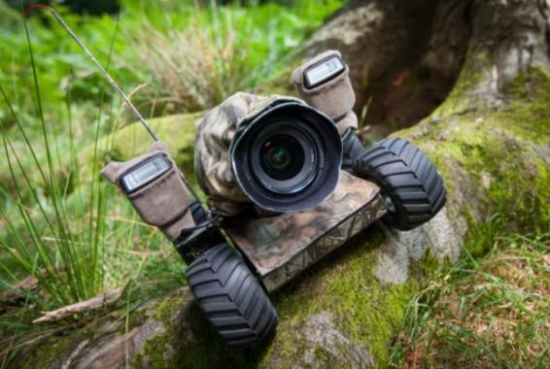Therefore, when we try to find out a solution for this we came across with some similar projects.

## Beetle cam for wildlife photography

Beetle cam has designed to take wildlife photographs. Wildlife photographer Will Burrard-Lucas had long wanted to add up-close-and-personal images of iconic African animals to his portfolio. But to get those intimate shot of lions and leopards, he would need to crawl up right next to their sharp-toothed faces [03**]**

Figure 2‑1 Beetle cam

This beetle cam can move forward and backward by using the remote controller. And also, beetle cam can be turned by using the wheels.

In our product we have all the functionalities same as the beetle cam. But there are some uncommon functionalities rather than this beetle cam. There is a special feature that can move the camera to the location easily by using GPS location guiding and can avoid obstacles itself. And also, can rotate the camera vertically using the remote controller. There is a siren for the safety of the camera.

## VCT-VPR1 Remote Control Tripod

This tripod has been designed to hold a camera and this is controlled by a remote controller. This tripod can check vertical and horizontal alignment using a grid line button. And also bring the subject closer with the zoom controller in the remote.

# Aim & Objectives

## Aim

This project aims to the distance photography process to make sure it is safer and effective.

## Objectives

The objectives of the project are as follows,

* Rotate the camera both vertically and horizontally.
* Move the stand according to the given GPS coordinates.
* Reach the target safely.
* Protect the camera from the animals by using the alarm.
* Control the camera holder using a remote controller.

# Analysis and Design

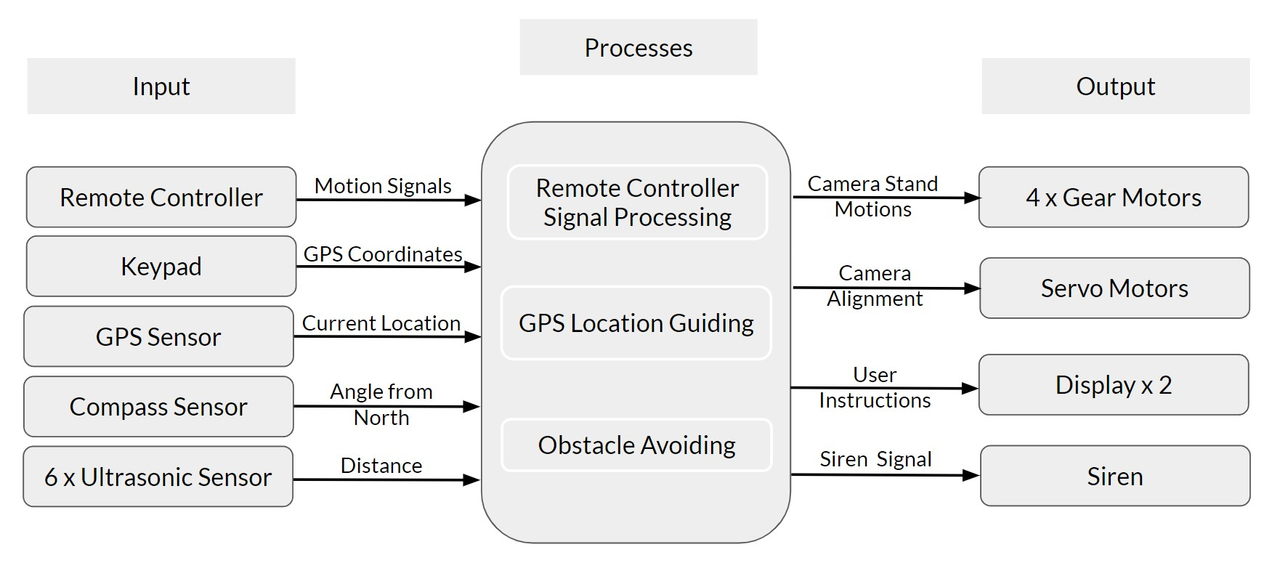

Figure 4‑1 Block Diagram of Proposed System

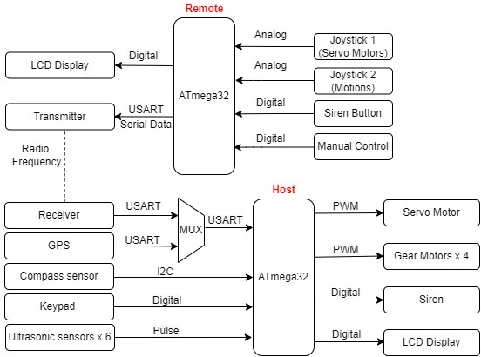

Figure 4‑2 System Diagram of Proposed System

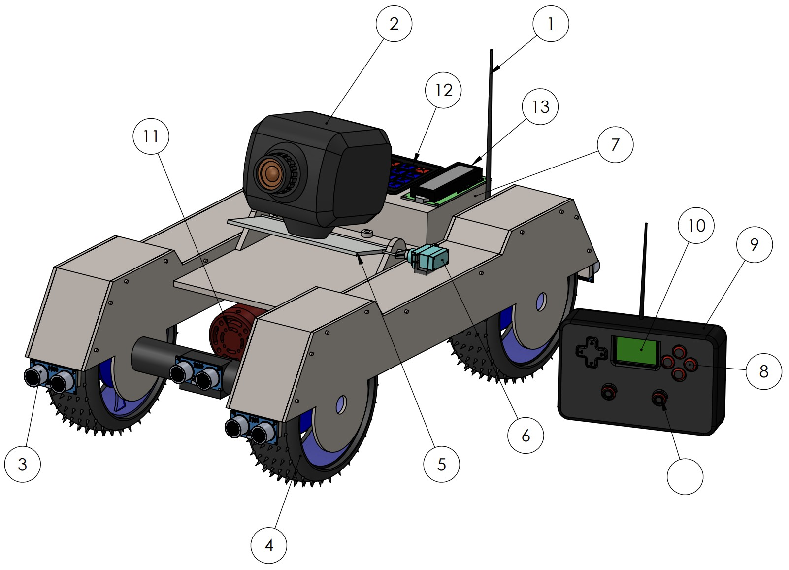

14

*Figure 4-7 Named Camera Stand 3D view*

1. RF Antenna
2. Camera
3. Ultrasonic sensors
4. Wheels with gear motors
5. Universal camera mount
6. Servo motor
7. Project box
   1. Atmega32 IC
   2. Compass sensor
   3. RF receiver
   4. GPS module
8. Remote controller buttons
9. Remote controller
10. LCD Display
11. Siren
12. 4x4 Numpad
13. LCD Display
14. Joystick

# Testing and Implementation

In our project, there are two ATmega32 microcontrollers, one is for remote controller and the other one is for the host (Camera stand). The microcontroller takes inputs related to motions and angles from two joysticks. The microcontroller of the remote processes the data and transmit from remote to host through RF (Radio Frequency) modules.

Then the microcontroller of the host gets data from the RF receiver module and GPS module using a 2×1 multiplexer. And also, the microcontroller of the host takes inputs from ultrasonic sensors, compass sensor and the keypad. The microcontroller of the host processes that data and send data to the servo motors and gear motors. And also send digital signals to the display and the siren.

## Thumb Joystick

These joystick modules are used to control movements of the camera stand and the vertical camera angle.

 Joystick is an input device. Analog joystick is sometimes called as Control Stick. It is used to control the pointer movement in 2-dimension axis.   It is made by mounting two potentiometers at a 90 degrees angle to read user’s input.  The potentiometers are connected to a short stick centered by springs. One potentiometer is used to get the analog output voltage for X-Direction movement related to move the camera stand forward backward and the other potentiometer is used to get the analog output voltage for Y-Direction movement related to move the camera stand left right. The potentiometers are connected between +VCC and Ground. They simply behave as voltage divider network. The joystick has one freewheeling Holder. According to the holder movement, the potentiometer knob changes its position and resistance of the potentiometer. This module produces an output of around 2.5V from X and Y when it is in resting position. Moving the joystick will cause the output to vary from 0v to 5V depending on its direction. If we connect this module to a microcontroller, we can expect to read a value of around 512 in its resting position. When we move the joystick, we should see the values change from 0 to 1023 depending on its position. Operating Voltage is 5V.  Operating current is 3.5 mA. Internal potentiometer value is 10kΩ.Operating Temperature is 0 to 70°C. There are five pins such that Ground pin, Vcc, VRx, VRy and Switch pin.

## Liquid Crystal 16 × 2 Display

These LCD displays are used to show GPS coordinates and the current remote's configurations. By using this we can convert camera stand more user friendly.

## Motor drive

Motor drive is used to amplify the PWM signal from the Atmega32 and supply it to the gear motors.

## Servo Motor

This servo motor is used to change the vertical angle of the camera. Servo motor is used to change the vertical angle of the camera. A servo motor is an electromechanical device that produces torque and the velocity based on the supplied current and voltage. A servo motor works as part of a closed loop system providing torque and velocity as command from a servo controller utilizing a feedback device to close the loop. The feedback device supplies information such as current, velocity or position to the servo controller, which adjusts the motor action depending on the command parameters.

In our project, Servo motors is used for changing the vertical angle of the camera within 90 degrees. When we take a photo of a wild animal, we have to change the orientation of the camera according to the orientation of the animal.

When the signal is received to the Atmega32 microcontroller in the host, it provides a signal to the servo motors to make the correct angle of the servo motors. For that we use the PWM method to process that.

 Servo motor has three colour wires. The red colour wire should be connected to the power supply. Brown colour wire connects to the Ground and the Orange colour wire connects to the PWM signal given by the Atmega32 in the host. These are the specifications of the servo motor, speed is 0.1 per second, torque is 2.5kg per cm, weight is 14.7 g and operating voltage is 4.8V to 6V.

## Siren

The siren is used to protect the camera stand. when the wild animals come to the attack the camera stand, just sound the siren for run off the animals. These are the  specifications of the siren , operating maximum voltage is 12V, operating maximum current is 6 A, Sound intensity is 112 -116 decibels and speed is 1000 rpm.

## RF Receiver and Transmitter

We use a 433 MHz RF module to maintain the communication between the remote controller and the host. RF module, as the name suggests, uses radio frequency to send signals. These signals are transmitted at a particular frequency and a baud rate. A receiver can receive these signals only if it is configured for that frequency. Out of that I am responsible for transmitter module. The transmitter module takes serial input and transmits these signals through RF.

The t**ransmitter module consists of four pins namely Vcc, ground, ATAD, and optional ANT** pin as shown. The Vcc pin has a wide range input voltage from 3V to 12V. The transmitter consumes a minimum current of 9mA and can go as high as 40mA during transmission. The ATAD pin is the data pin to transmit the signal. This signal modulated and then sent on air at a frequency of 433MHz. This module has an antenna pin which helps to connect the external wire to extend the range up to 100 meters. The size of the antenna will depend on the operating frequency.

The RF transmitter receives serial data and transmits it wirelessly through its RF antenna. The transmission occurs at the rate of 1 Kilobits per second to 10 Kilobits per second.

## Gear motor

A gear motor is an all-in-one combination of a motor and gearbox. The addition of a gear head to a motor reduces the speed while increasing the torque output. The most important parameters in regard to gear motors are speed (rpm), torque and efficiency. In order to select the most suitable gear motor load, speed and torque required for the application have to be measured correctly. Most of DC motors can be complemented with unique gearheads.

Reference for the gear motor: https://islproducts.com/design-note/dc-motor-dc-gear-motor-basics/

## Ultrasonic sensor

## An ultrasonic sensor is an electronic device which measures the distance to an object by emitting an ultrasonic sound wave and converts the reflected sound into an electrical signal. Ultrasonic waves travel faster than the speed of audible sound. Ultrasonic sensors have two parts as the transmitter and receiver. Transmitter send an ultrasonic sound wave and then the receiver receives that wave and calcite the time took to come back to the receiver. And using these data ultrasonic sensor calculates the distance which have to that particular object. This is the way how the ultrasonic sensor works.

Reference for the gear motor: https://www.fierceelectronics.com/sensors/what-ultrasonic-sensor

## 4x4 Keypad

This is consist of 4 rows and 4 columns which consist of

## GPS module

The GPS module uses the USART technology to communicate with the microcontroller. And when taking the specifications of the microcontroller, the operating voltage lies between 2.7V to 3.6V.In the GPS module, there is a GPS antenna to take GPS signals through Radio Frequency which are sent from the GPS satellites. Its serial baud rate lies between 4800 bits per second to two lakhs thirty thousand four hundred bits per second. But the default serial baud rate is nine thousand six hundred. The max supply current for this module is 67 mA.

When taking the pin configuration of the GPS module, there are 4 pins. Vcc pin is for power supply and GND pin is used to ground the GPS module. TXD pin is for the transmission of data and the RXD pin is for the receiving of data. In this project, I have only to transfer data from the GPS module to the Atmega32 chip, and therefore I was only needed to connect the TXD pin of the GPS module with the atmega32 RXD pin. RXD pin is the 14th pin. This is all about the pin configuration of the GPS module.

## Compass sensor

For the GPS location guiding algorithm, identifying the current facing direction of the camera stand is a must. The module used is the HMC5883L magnetometer module. This uses the I2C protocol for communication with the Atmega32 microcontroller. According to the documentation, the supply voltage for the magnetometer module lies between 2.7 V to 6.5 V. The max voltage is 6.5 V. The frequency to pass serial data is up to 400kHz and the operating temperature is between -22 to 185 Fahrenheit. The pin configuration is that there are 5 pins in the magnetometer module. The Vcc pin takes power to the module, and the GND pin is to ground. SCL is the serial clock pin, and the SDA is the serial data pin. DRDY is the data-ready interrupt pin.

# Previous Action Plan

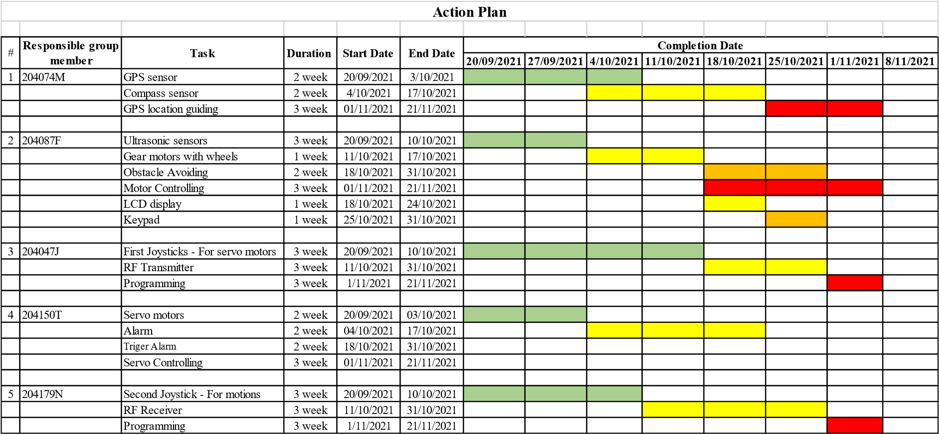

# Action Plan for Remaining Work

|  |  |  |  |  |  |  |  |  |  |  |  |
| --- | --- | --- | --- | --- | --- | --- | --- | --- | --- | --- | --- |
|  |  |  | **Action Plan** | | | | | | |  |  |
|  |  |  |  |  |  |  |  |  |  |  |  |
|  | **Responsible group member** | **Task** | **Duration** | **Start Date** | **End Date** | **Completion Date** | | | |  |  |
| **31/12/2021** | **31/1/2022** | **1/2/2022** | **1/3/2022** | **1/4/2022** | **9/5/2022** |
| 1 | 204074M | Compass sensor | 1 month | 31/12/2021 | 31/1/2022 |  |  |  |  |  |  |
|  |  | GPS location guiding | 1 month | 1/2/2022 | 1/3/2022 |  |  |  |  |  |  |
|  |  | Test and implementation | 2 months | 2/3/2022 | 9/5/2022 |  |  |  |  |  |  |
|  |  |  |  |  |  |  |  |  |  |  |  |
| 2 | 204087F | Obstacle Avoiding | 1 month | 31/12/2021 | 31/1/2022 |  |  |  |  |  |  |
|  |  | Motor Controlling | 1 month | 1/2/2022 | 1/3/2022 |  |  |  |  |  |  |
|  |  | Test and implementation | 2 months | 2/3/2022 | 9/5/2022 |  |  |  |  |  |  |
|  |  |  |  |  |  |  |  |  |  |  |  |
| 3 | 204047J | First Joysticks - For servo motors | 1 month | 31/12/2021 | 31/1/2022 |  |  |  |  |  |  |
|  |  | RF Transmitter | 1 month | 1/2/2022 | 1/3/2022 |  |  |  |  |  |  |
|  |  | Test and implementation | 2 months | 2/3/2022 | 9/5/2022 |  |  |  |  |  |  |
|  |  |  |  |  |  |  |  |  |  |  |  |
| 4 | 204150T | Servo motors | 1 month | 31/12/2021 | 31/1/2022 |  |  |  |  |  |  |
|  |  | Test and implementation | 1 month | 1/2/2022 | 1/3/2022 |  |  |  |  |  |  |
|  |  | Trigger Alarm | 1 month | 2/3/2022 | 1/4/2022 |  |  |  |  |  |  |
|  |  | Servo Controlling | 1 month | 2/4/2022 | 9/5/2022 |  |  |  |  |  |  |
|  |  |  |  |  |  |  |  |  |  |  |  |
| 5 | 204179N | Second Joystick - For motions | 1 month | 31/12/2021 | 31/1/2022 |  |  |  |  |  |  |
|  |  | RF Receiver | 1 month | 1/2/2022 | 1/3/2022 |  |  |  |  |  |  |
|  |  | Test and implementation | 2 months | 2/3/2022 | 9/5/2022 |  |  |  |  |  |  |

Appendix A

# Cost Estimation and Expenditure so far

|  |  |  |  |
| --- | --- | --- | --- |
| **Component** | **Unit Price** | **Quantity** | **Price (LKR)** |
| 68mm RC Car Tire Wheel | Rs. 300.00 | 4 | Rs. 1,200.00 |
| Liquid Crystal 16x2 Display Module | Rs. 300.00 | 1 | Rs. 300.00 |
| 2 Pin Switch | Rs. 15.00 | 2 | Rs. 30.00 |
| Thumb Joystick Module | Rs. 150.00 | 2 | Rs. 300.00 |
| RF 433MHz Transmitter/Receiver | Rs. 200.00 | 1 | Rs. 200.00 |
| GY-271 Electronic Triple Axis Compass Module | Rs. 700.00 | 1 | Rs. 700.00 |
| Membrane Keypad - 16 Key | Rs. 180.00 | 1 | Rs. 180.00 |
| HC-SR04 Ultrasonic Sensor Module | Rs. 200.00 | 6 | Rs. 1,200.00 |
| NEO-6M GPS Module | Rs. 1,850.00 | 1 | Rs. 1,850.00 |
| L298N DC Motor Driver Module | Rs. 350.00 | 2 | Rs. 700.00 |
| Servo Motor | Rs. 750.00 | 1 | Rs. 750.00 |
| Atmega32 Microcontroller | Rs. 550.00 | 2 | Rs. 1,100.00 |
| 11.1V 2200mAh 3S 25C Li-Po Battery | Rs. 2,800.00 | 1 | Rs. 2,800.00 |
| 12V 2000mAh Li-Po Battery | Rs. 1,750.00 | 1 | Rs. 1,750.00 |
| DC Gear Motor 12v 180 RPM | Rs. 950.00 | 4 | Rs. 3,800.00 |
|  |  | Total | Rs. 16,860.00 |

[4],[5]

# *Appendix B*

# Individual Contribution to the Project

## P.A.U.D. Herath - 204074M

I studied about the GPS module. Studied about the way how the GPS signals generate and the way of GPS working. Learned about the theory regarding the USART communication. Understood the theory behind the multiplexer to connect the GPS module and the compass sensor module.

### GPS module (NEO-6M)

The GPS module has a GPS antenna, battery, an EEPROM and a position fix LED indicator. The pins in the NEO-6M are VCC, Tx, Rx and GND. Understood that the D0 and D1 pins must be used to take the serial data using the GPS module. Specifications are that the Operating Voltage is 2.7V - 3.6V. The serial Baud rate lies between 4800 and 230400. The default baud rate is 9600. The operating current of the NEO-6M GPS module is 45mA.

### Multiplexer

When taking the inputs related to the GPS module and the receiver, I had to use the same pins D0 and D1. Therefore, I used a multiplexer to carry this out.

### USART communication

To take the serial inputs from the GPS module, I used the USART method.

## P.H.P. Jayathilaka 204087F

I have studied about Ultrasonic sensors, Display, Keypad, ADC, PWM. I have started studying about USART. Also, started to study interfacing components with the ATmega32 microcontroller and how to connect components to the microcontroller.

### Ultrasonic sensor (HC-SR04)

I am using 6 ultrasonic sensors to avoid obstacles. There are 4 pins in the ultrasonic sensor. (VCC, Trig Pin, Echo Pin, GND)

These are the specifications of Ultrasonic sensor. The working power of the ultrasonic sensor is DC 5Vand 15mA,

Working frequency is 40Hz, accurate range is 2cm – 40cm,

Measuring angle is 15 degrees, trigger input signal is 10µS TTL pulse

echo output signal input TTL lever signal and the range in proportion

### 9.2.2 Gear Motors

Due to lack of eight PWM pins for four motors, I had to couple motors as left and right. Then needed PWM pins reduced to four. Furthermore, I used only one PWM pin and a digital pin per side. It is configured by code.

These are the specifications of gear motors

the working voltage is 12V DC, Speed is 180 RPM,

It is a high torque motor and use L298NH – bridge motor drive

## D.M.B.M. Dissanayake - 204047J

I have studied about Joystick, RF Transmitter and ADC. I have started to study interfacing components with the ATmega32 microcontroller and how to connect components to the microcontroller.

In our project, I used a joystick to get inputs related to the angle of servo motors. The microcontroller of the remote gets analog inputs from this joystick. We need knowledge about ADC on AVR ATmega32 to process that analog signal. To get this analog input, I had to use A0 pin in the ATmega32 microcontroller. Furthermore, I used a 433 MHz RF transmitter to transmit the above-processed data from the microcontroller.

### Thumb Joystick

There are 5 pins in the joystick module.

VCC, GND, VRx, VRy, SW

Specifications of thumb joystick module, operating voltage is 5V. Internal potentiometer value is 10kΩ. Operating Temperature is 0 to 70 C֩.

There is no joystick module in proteus. Therefore, I used a variable resistor to connect with the microcontroller.

## S.P.S.N. Pathirana 204150T

  As a member of our group, I have to work with a servo motor and a siren. First, I studied about the servo motor, and the siren. Second, I selected a suitable type of servo motor and a siren. After that, I started to learn about how they are working. Finally ,started to learn about how they are interfacing with Atmega32 microcontroller

In this project, servo motor is used to change the vertical angle of the camera, according to the signal of the joystick.

### Servo Motors

These are the specifications of servo motor:

The speed of the servo motor is 0.1 per second.

Torque is 2.5 kg/cm. The weight is 14.7g and

the voltage is 4.8V – 6V

### Siren

We used a siren to protect the camera stand. when the wild animals come to the attack the camera stand, we just sound the siren for run off the animals. The siren sounds according to the signal given by the siren button in the remote controller. These are the specifications of the siren, operating maximum voltage is 12V, operating maximum current is 6 A, Sound intensity is 112 -116 decibels and speed is 1000 rpm.

## A.M.D.B. Rathnayaka 204179N

I studied about the joystick, RF receiver, ADC Technology and started to learn about how the components are working and interfacing with ATmega32 microcontroller. In our project, I have to give inputs to the ATmega32 microcontroller of the remote from the joystick. Moreover, it gives inputs to the microcontroller of the host from the RF receiver.

### 433 MHz Receiver

Receiver uses the USART communication to communicate with the Atmega32 microcontroller of the host. The operating frequency is 433 MHz, the operating voltage is 5V and the supply current is 3.5 mA.

### Thumb Joystick

There are 5 pins in the joystick module. And the pins in this module are VCC, GND, VRx, VRy, SW. The Operating Voltage is 5V. The   Internal potentiometer value is 10kΩ and the operating temperature is 0 to 70 C֩. There is no joystick module in proteus. Therefore, I used two variable resistors to connect with the microcontroller.

# *Appendix C*

# References

1. A. Duke, “Hiker photographs bear just before fatal grizzly attack,” *CNN*, 26-Aug-2012.

1. J. Dempsey, “Introduction to wildlife photography: A guide for beginners,” *Phototraces.com*, 03-Jan-2020. [Online]. Available:

https://www.phototraces.com/b/wildlife-photography/. [Accessed: 28-Nov-2021].

1. M. Gallucci, “These robots are transforming how we see wildlife,” *Mashable*, 12-Jan2017. [Online]. Available: https://mashable.com/article/robots-wildlife-photography. [Accessed: 28-Nov-2021].

1. “Microchip.lk – one stop for all your electronics…,” *Microchip.lk*. [Online]. Available: https://microchip.lk/. [Accessed: 28-Nov-2021].
2. “TRONIC.LK,” *Lankatronics.com*. [Online]. Available: https://lankatronics.com/. [Accessed: 28-Nov-2021].